Single Administrative Domain

🌐 What Is Single Administrative Domain?
# Source: AI Source: Provided by: [Data Path: Persons Table -> ID Column: 1, Name_En Column: Motasem Essam] -> From: [ChatGPT] on [1/16/2026]
A single administrative domain refers to a network or group of networks that is managed and controlled by one organization or authority, which enforces a consistent set of routing, security, and management policies across the entire domain.

🧠 Simple Definition:
# Source: AI Source: Provided by: [Data Path: Persons Table -> ID Column: 1, Name_En Column: Motasem Essam] -> From: [ChatGPT] on [1/16/2026]
A single administrative domain is a collection of network devices and systems governed by one entity (like a company, ISP, or university), where all internal decisions — like routing, access control, and network design — are made centrally.

🎯 Key Characteristics
# Source: AI Source: Provided by: [Data Path: Persons Table -> ID Column: 1, Name_En Column: Motasem Essam] -> From: [ChatGPT] on [1/16/2026]
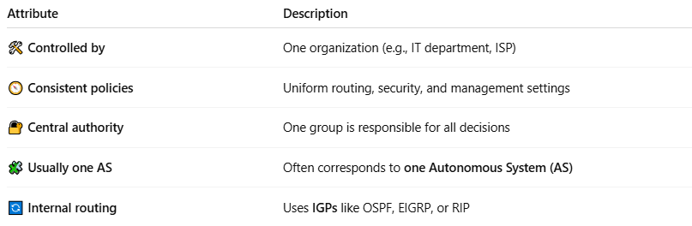

Attribute | Description
🛠 Controlled by | One organization (e.g., IT department, ISP)
🧭 Consistent policies | Uniform routing, security, and management settings
🔐 Central authority | One group is responsible for all decisions
🧩 Usually one AS | Often corresponds to one Autonomous System (AS)
🔄 Internal routing | Uses IGPs like OSPF, EIGRP, or RIP

🏢 Real-World Examples
# Source: AI Source: Provided by: [Data Path: Persons Table -> ID Column: 1, Name_En Column: Motasem Essam] -> From: [ChatGPT] on [1/16/2026]


Entity | Description
🌐 An ISP (e.g., Vodafone) | Manages its own backbone and customer routes under one policy
🏢 A corporation (e.g., IBM) | All internal office networks, datacenters, and VPNs managed by one IT team
🏫 A university campus | Shared infrastructure managed centrally by campus IT

📡 Related Concepts
# Source: AI Source: Provided by: [Data Path: Persons Table -> ID Column: 1, Name_En Column: Motasem Essam] -> From: [ChatGPT] on [1/16/2026]
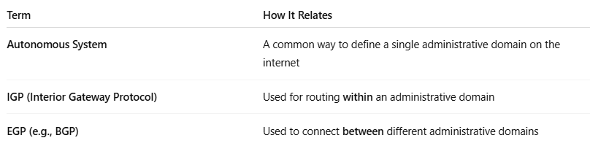

Term | How It Relates
Autonomous System | A common way to define a single administrative domain on the internet
IGP (Interior Gateway Protocol) | Used for routing within an administrative domain
EGP (e.g., BGP) | Used to connect between different administrative domains

✅ Summary
# Source: AI Source: Provided by: [Data Path: Persons Table -> ID Column: 1, Name_En Column: Motasem Essam] -> From: [ChatGPT] on [1/16/2026]

Term | Definition
Single Administrative Domain | A network or set of networks under the control of one authority, using consistent policies and routing rules

